Multilingual Collect! and Microsoft Word
A Powerful Combination

You can connect Collect! directly with Word and Open Office so when you move from debtor to debtor the text in the Word document automatically updates with current debtor information.

This feature also works beautifully with Collect!'s multi-language and multi-currency capabilities. The pictures below show examples.
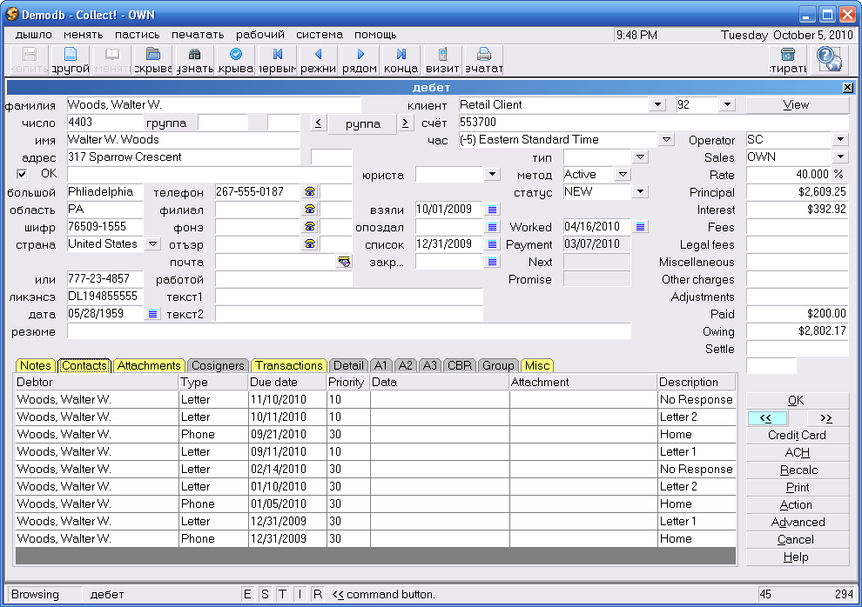

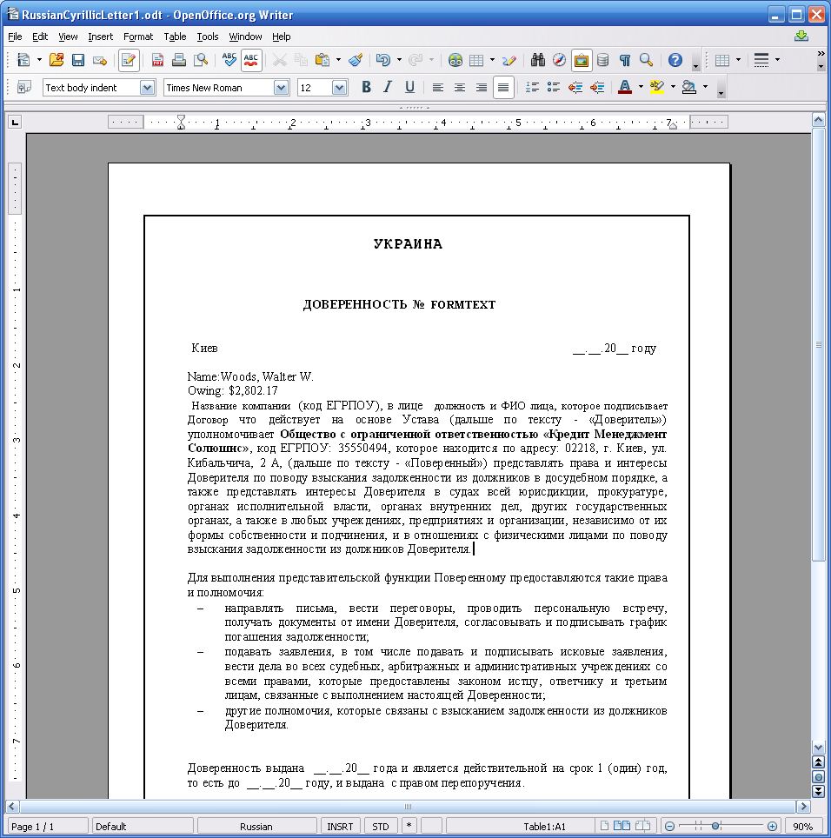

- Notice the account name from Collect! appears in the Word document.
- You can have any information from the Debtor form inserted in the Word document.
- You can have even manage different languages and currencies at the same time.

Multilingual Collect! and Microsoft Word

Collect! Multi-Language and Multi-Currency Support

No matter what your language or currency Collect! works for you.

Below you can see a Cyrillic letter and the debtor on the Collect! screen. See how the currency and the debtor name Cyrillic script is used in the Word document. It all flows together quite naturally.

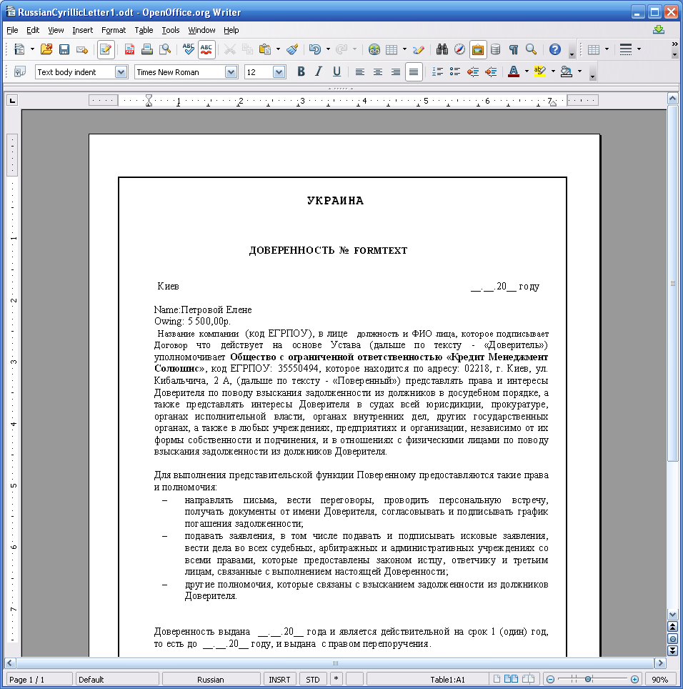
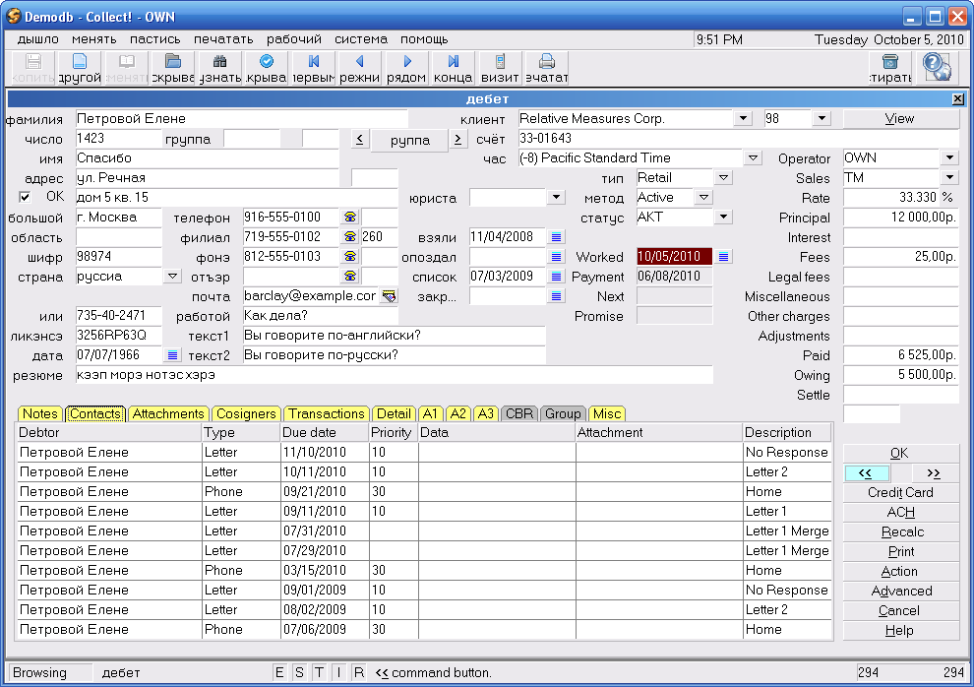
Giving you the ultimate in flexibility the Collect! Dynamic Data Exchange (DDE) system is a powerful tool to help you streamline and automate your operations.

For more information check out the member center at collectsoftware.com

*** END ***

